2023 Membership Application
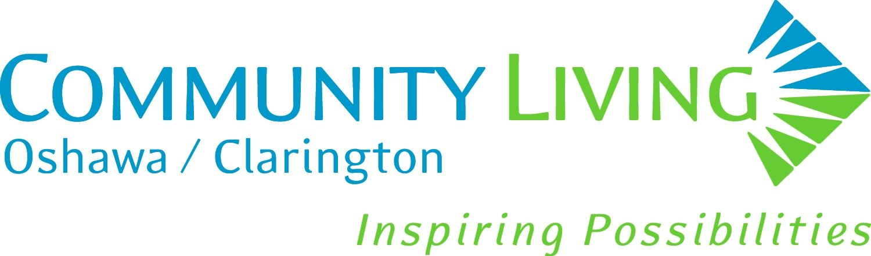
2023 Donation Form

Please return to: 39 Wellington Avenue East, Oshawa, ON L1H 3Y1

Membership with Community Living Oshawa/Clarington keeps you updated on current developments and news affecting people living with developmental disabilities in Durham Region and Ontario. Membership is also vital to the work of CLOC, our ability to provide high quality services, to fundraise and to maintain connection with our stakeholders. With a strong and active membership, the future of Community Living’s services is guaranteed for years to come.

YOUR INFORMATION

Name:

Address:

City: ___________________ Postal Code: _____________

Telephone: ____________________________ Email: _________________________________________

TYPE OF MEMBERSHIP (please check)

Person Receiving Supports and/or Services from CLOC
Benefits: Voting at membership meetings, Newsletter, Event Discounts, Forum Invites, Updates from CLOC and Community Living Ontario
Cost: Free

Individual Membership
Benefits: Voting at membership meetings, Newsletter, Event Discounts, Forum Invites, Updates from CLOC and Community Living Ontario
Cost: $10.00

IS THIS A NEW MEMBERSHIP OR RENEWAL (please check)? New Renewal

Please note that no matter when purchased, all memberships are valid from January 1 to December 31, of the current year.

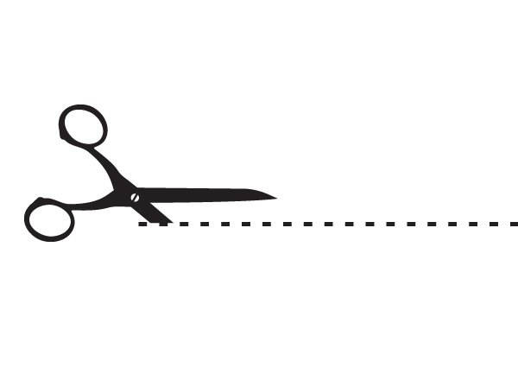
Please retain this portion of the form as your Proof of Membership.

Your Proof of Membership may be used when attending Family & Membership Meetings, Annual General Meeting, or when exercising your right to vote.

Membership is valid from January to December
Name of Member

2023 Membership Application
2023 Donation Form

Some points of interest here at CLOC are:

- ‘Round the CLOC’ Newsletter – available every other month

- Family & Membership Meetings – June and November each year
(We are always looking for an opportunity to present information on topics ‘you’, the family members, and membership would like to hear about. Submit suggestions to a support worker at your home, Residential Supervisor, Manager, Operations or e-mail Wendy Shaw at wshaw@communiitylivingoc.ca or 905-576-3011 ext. 330.)

- Committee opportunities – If you, or someone you know is interested in volunteering to sit on a committee, please contact wshaw@communitylivingoc.ca or 905-576-3011 ext. 330.

- In past years we have offered social events, such at our Annual Gala, The Clarington Gala, the Annual Golf Tournament, Euchre night, BBQs and various other activities. Be sure to let us know if there is something you are interested in, and we may be able to add it to our calendar. Be sure to give us enough notice as many of our events are run by volunteers and employees who are going above and beyond their regular workload.

MEMBERSHIP PAYMENT

Cash Cheque Credit Card (VISA, Mastercard, AMEX) Amount $ __________

DONATION

I wish to make a donation to CLOC in the amount of $ _________. Cash Cheque Credit Card

Payments may be made by e-transfer to cnighbor@communitylivingoc.ca .
Please include CLOC MEMBERSHIP in the message.

Donations of $10 or more will be provided with a charitable tax receipt as per Revenue Canada guidelines.

CLOC’s Mission Statement

CLOC is a charitable organization offering opportunities for personal growth, community inclusion and empowerment to people with developmental disabilities, and their families.

